**PA - 303.5.1 - Practice Assignment - Loops**

**Objective:**

In this assignment, you will create a Java program. Requirements are given below. This assignment will test your knowledge of Control Flow (Conditional) Statements and loops in Java.

**Tasks:**

# 1: Print a Multiplication Table

Write a program that uses nested **for loops** to print a multiplication table.

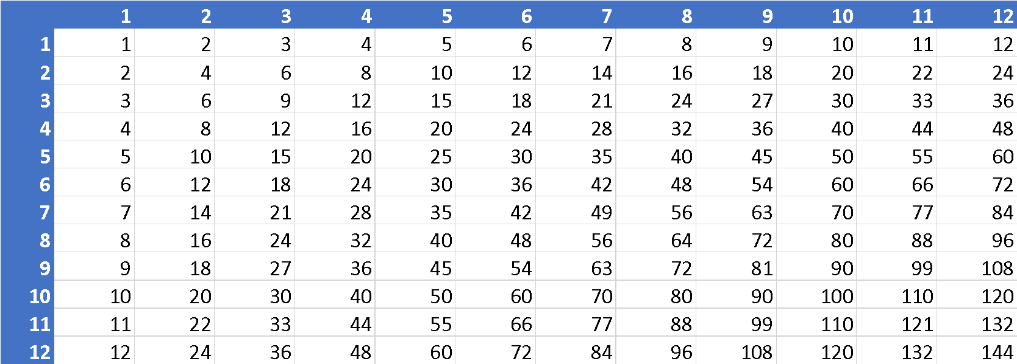

# **2: Find the Greatest Common Divisor**

* Write a program that prompts the user to enter two positive integers, and find their greatest common divisor (GCD).
* Examples:
  + Enter 2 and 4. The gcd is 2.
  + Enter 16 and 24. The gcd is 8.
* How do you find the gcd?
  + Name the two input integers *n1* and *n2*.
  + You know number 1 is a common divisor, but it may not be the gcd.
  + Check whether k (for k = 2, 3, 4, and so on) is a common divisor for n1 and n2, until k is greater than n1 or n2.

# 3: Predict Future Tuition

* Suppose the tuition for a university is $10,000 for the current year and increases by 7 percent every year.
* In how many years will the tuition be doubled?

| Year | Tuition |
| --- | --- |
| 0 | $10,000 |
| 1 | tuition = 1.07 * tuition |
| … | tuition = 1.07 * tuition |
| … | tuition = 1.07 * tuition |
| … | … |
| ? | $20,000 or more |

**Submission Instructions:**

Include the following deliverables in your submission -

* + Submit your source code using the Start Assignment button in the top-right corner of the assignment page in Canvas.

**CANVAS STAFF USE ONLY: Canvas Submission Guideline:**

| **Instructions for Canvas Assignment Creation** |
| --- |
| **Assignment Name: PA 303.5.1 - Practice Assignment- Loops**  **Points:** **100**  **Assignment Group: Module 303: Java SE Review (Not Graded)**  **Display Grade As: Complete/Incomplete**  **Do not count this assignment towards the final grade: Checked**  **Submission Types:Files Uploads**  **Everything else is the default.** |